|  |  |  |  |
| --- | --- | --- | --- |
|  | Participants |  | List of registered participants **[Alvaro]** |
| 12:00 | Agenda |  | Meeting starts - duration - 3 hours |
| 12:00 -12:15 | Welcome /Logistics |  | Welcome and Logistics **[Jeff / Alvaro]** |
| 12:15 - 14::55 | **Github Issues** | Issue # 22 | Portrayal Proposals - workflow and form |
|  | Issue # 23 | Review the need for new symbology |
|  | Issue # 21 | S101 ECDIS Performance Req. log |
|  | Issue # 7 | Quality of Bathymetric Data |
|  | Issue # 1 | QoBD - Visualization of Vertical and Poistional uncertainties |
|  | Issue # 4 | QoBD - Temporal variation |
|  | Issue # 2 | Fairway portrayal |
|  | Issue # 3 | Light sector portrayal |
|  | Issue # 6 - 18 | NIWC Testbed update |
|  | Issue # 19 | ENC Display' subWG |
|  | Issue # 20 | ECDIS Chart 1 |
|  | Issue # 5 | Grouping of soundings in ENC Updates |

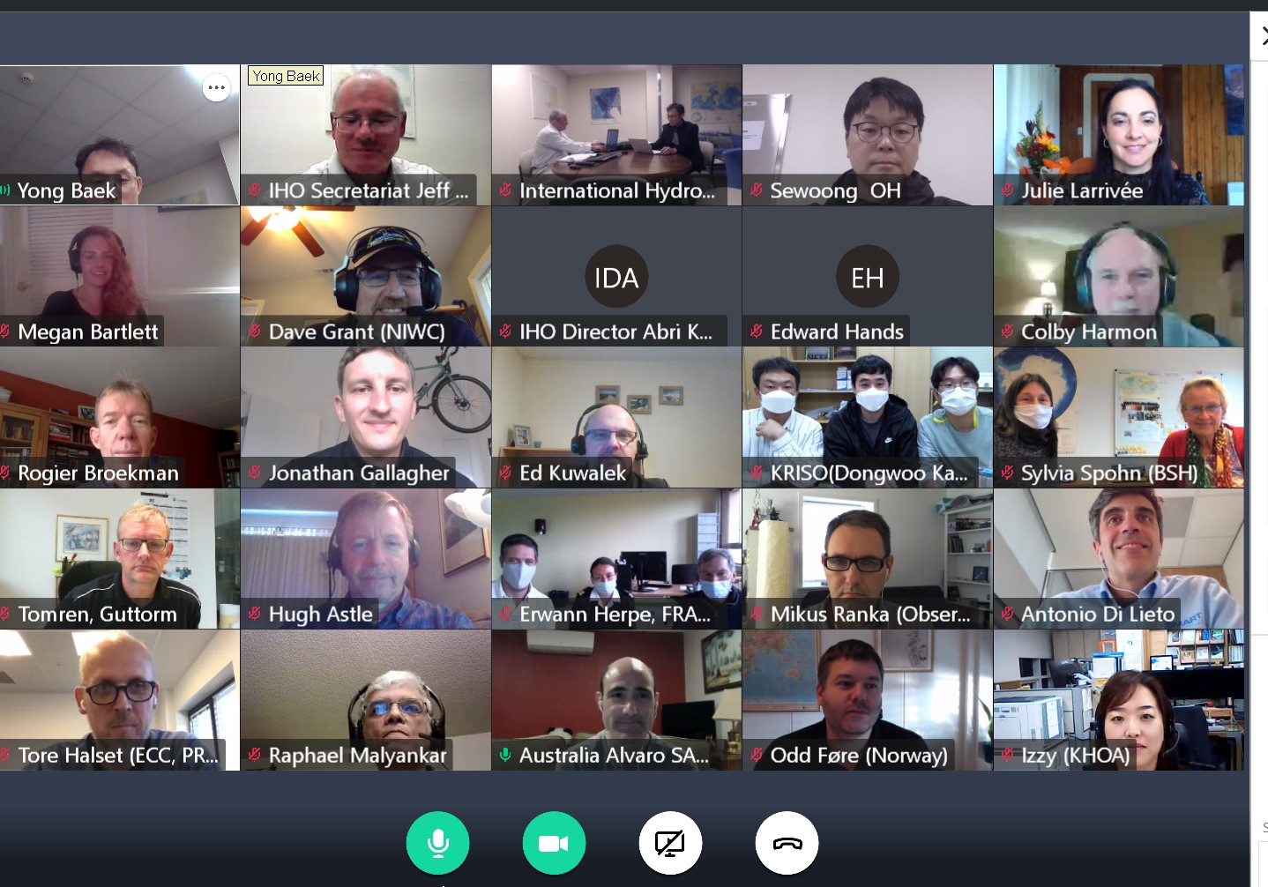

Alvaro stressed the importance of having a good cross-section of participation (cartographers/encoders; data modellers; industry) in the Sub-Group.

Focus of the WG: Completeness of the S-101 PC. Yong also stated that this “completeness” also required development and implementation of the portrayal rules. The group should develop, test then register. This was confirmed by Alvaro. Yong: Perhaps also develop a guideline for proposals (colour recommendations etc).

Github link and access information to be supplied to Sub-Group (again). All members should create an account on Github to be able to comment on proposals.

Yong general comment: The group needs to focus on the development of the next PC to align with the next version of the FC (Edition 1.0.1). This was agreed, noting however that other issues will need to be prioritized accordingly.

**Issue # 22:** Portrayal Proposals - workflow and form: How are people going to be aware of or access the form. Workflow and form approved, will be posted on Github.

Need to have consistency between the form and the Registry proposal to avoid confusion.

|  |
| --- |
| *Action*: Alvaro to address this (with IHO Sec). |

Hugh Comment: It would be nice if the issues had more meaningful descriptions instead of like "slide #32". The

Chat comment from Hugh: Portrayal Catalog is XML files and code. We could have a working draft on Github in the code section and use issues to discuss changes.

Tore Comment: GitHUB issues work well for us (ECC). It would be very good if we also could provide pull requests for code changes to the PC as well. That would make it easier for us to contribute.

Dave comment: If the group identifies a repo we can move PC development to it. We currently use an internal GitLab repo. Yong: This Github will move under the IHO Github.

Refer to Action associated with Issue # 6 below.

**Issue # 23:** Review the need for new symbology: Referenced the Differences spreadsheet. Alvaro has added some additional columns (Github) for evaluation and decision making. Suggested that the group needs to work through this spreadsheet. Noted that as S-101 is constantly evolving, the spreadsheet would need almost continual updating. Suggestion was to have each line of the spreadsheet as an Issue in Github but it was decided that it will be labour intensive and could delay the action.

|  |
| --- |
| *Action*: IHO Sec and Alvaro to consolidate the list of items in the spreadsheet that do not require further action in regard to symbology for the Sub-Group to review. All further action items will be managed in Github. |

**Issue # 21**: S101 ECDIS Performance Requirements log: Need to identify who is going to be going through the cross-reference. Jonathan (IIC) will continue to do this work. (Need to confirm with Jonathan).

|  |
| --- |
| *Action*: Establish an ECDIS Performance Requirements log of S-101 specific ECDIS performance issues. It would consist of:   * existing S-101 specific issues *(already migrated to the first draft version of S-98 Annex-C /// 1) requires a ‘gap analysis’ to ensure completeness and 2) S101 specific requirements will need to be identified and separated from the rest)* plus * new S-101 specific requirements that, although having been evaluated and approved in concept by the S-101PT, can’t be implemented in DF ECDIS and therefore their development and testing can be delayed.   Alvaro to create draft version and distribute for comments. |

**Issue # 7:** Quality of Bathymetric Data: Alvaro has consolidated all the papers/information that he has on this issue in the Github. Suggested that members read these documents. The Sub-Group can then discuss further and develop some concrete proposals for the S-101PT.

Dave suggested breaking the issue into two parts: Expression of the current CATZOC values in terms of the new S-101 modelling; and the future symbolization of QoBD in S-100 ECDIS.

|  |
| --- |
| *Action*: Dave to liaise with Rogier (DQWG) and continue to work on the conversion rules for CATZOC/S-101 new modelling for submission to the Sub-Group.  *Action*: Recommend the S-101PT retain the current CATZOC symbology (after mapping to QoBD is resolved and approved) during the DF period and, in parallel, work towards a more holistic approach for the display and integration into ECDIS safety functions of the quality of bathymetric data information. |

**Issue # 1:** QoBD - Visualization of Vertical and Positional uncertainties: Agreed to wait on outcome on HSSC12 discussions and future modelling options to be presented to the DCEG Sub-Group.

Mention was also made of calculation of horizontal and vertical clearances. To be considered in future discussions.

**Issue # 4:** QoBD - Temporal variation: Proposal has been made by DQWG to remove this attribute from the QoBD feature. There have been some comments from MS (AU and FR in support of retaining and UK in support of removing).

|  |
| --- |
| *Action:* Sub-Group members to review the documents on Github and indicate their preference (remove or retain categoryOfTemporalVariation) **by 31 October 2020**. |

Sylvia: See my comment, but if the temporal variation was skipped already, we could accept it.

Rogier: In Netherland we are already downgrading our CATZOC values due to operational issues. We cannot maintain our re-survey policy at this time.

Rogier: If an individual sounding is shallower than the CATZOC value, it is possible to add SOUACC to those soundings. This should trigger alarms.

Further discussion: Proposal to add a “temporal validity” attribute. This would only be valid if categoryOfTemporalVariation is retained.

Rogier: In the paper source diagrams, the date of the survey was usually reported by the year. The Mariner was requested to combine this information for his assessment for route planning and execution.

|  |
| --- |
| *Action:* Sub-Group members to review the documents on Github and indicate their preference (add new QoBD feature attribute temporalValidity to the S101 FC and DCEG) **by 10 November 2020**. |

**Issue # 2:** Fairway portrayal: Edward (NO) described the issue, based on paper S-101PT5-14. Alvaro noted the issue of consistency between portrayals (S-101 and S-52) in duel-fuel ECDIS. Suggested some testing of the “lighter” magenta in the S-100 testbeds.

Sylvia provided some input as to the work being done within the NCWG.

|  |
| --- |
| *Action:* NIWC to implement different fain magenta colour(s) in the testbed (test data to be provided by Norway) and provide screenshots to NO for consideration and preparation of a formal proposal using the newly introduced online ‘*Portrayal changes request form’*.  Alvaro to move the proposal forward following the newly introduced ‘*Portrayal request workflow’*. |

**Issue # 3:** Light sector portrayal: Odd (NO) described the issue, based on paper S-101PT5-15.

|  |
| --- |
| *Action:* NIWC to include additional pictures and other information to facilitate the understanding of the type of input required from the members. Sub-Group members to review the documents on Github and provide input by **31 October 2020**. |

**Issue # 6:** NIWC Testbed update: Concern was raised over the validation of the content of the Portrayal Register.

Action: NIWC to identify any issues with the Portrayal Register (missing items etc) to IHO Sec to pass to KHOA for action.

Action: KHOA, NIWC and IHO Sec to move the latest NIWC version of the PC to the PS Register.

|  |
| --- |
| *Action:* NIWC and IHO Sec to create another Github repository within the IHO area (which may need some higher access restrictions) to manage the ongoing development of the NIWC PC. |

Raphael: I will be happy to discuss any discrepancies in viewing groups between the Annex C draft and draft S-101 PC with NIWC before things get entered into the registry.

**Issues # 8 to 18**: ENC Display' subWG: Out of time.

**Issue # 19:** ENC Display' subWG: Out of time.

**Issue # 20:** ECDIS Chart 1: Out of time.

**Issue # 5:** Grouping of soundings in ENC Updates: Out of time.

|  |
| --- |
| *Action:* Work to continue (all Sub-Group members) on issues via Github and correspondence. Alvaro to collate discussions for reporting to the S-101PT and possibly arrange future VTCs as required. |